**273/2 GEOGRAPHY**

1. R.S.A = X 3600 = 190.40 1900

Morocco = X 3600 = 1.80 20

Egypt = x 3600 = 85.60 860

Zambia = 3600 = 54.70 550

Ghana = x 3600 = 1.30 1.00

Malawi = x 3600 = 25.90 260 @ ½

cal 03

Acc 06

**PIE CHART SHOWING EXPORT EARNING FOR SELECTED AFRICAN COUNTRIES**

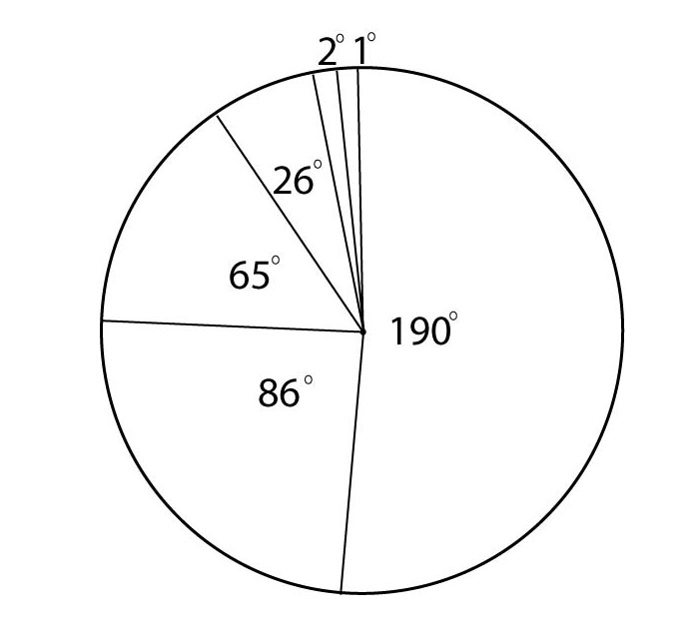

**09 marks**

(b). (i) Two manufactured goods exported by S. Africa include

Textiles. Soap, paints, furniture, beverages, glass, cement etc.

max 02 marks

**(ii)** **Conditions that led to higher export earnings from manufactured goods in R.S.A include**

* Production of high quality goods from R.S.A
* The relative political stability attracting a number of foreign investors
* Large supply of water for processing beverages
* Advanced technology used in the manufacture of final products
* Favourable government policies like protecting home industries
* Adequate and reliable transport network reaching the sea ports to outside world
* Increased publicity and advertisement leading to large and wide markets
* The skilled manpower that works in the manufacturing industry in the production process

Max 05 marks

c) **Contribution of industrial activities to the economy**

* They have led to the provision of employment opportunities to many people like technicians, drivers.
* A source of income to the manufacturer, helping to improve on the standards of living people.
* Source of revenue to the government through taxation of workers and the company
* They have led to development of infrastructure like roads, railways in the country
* If has led to development of town like Durban, Johannesburg
* Source of foreign exchange through exportation of raw material or fishers good
* Improvement of international trade and relations before south Africa and her trading partners

Id 3 max

Ex 3

Max 6 marks

d**) Steps being taken to maintain steady increase in exports include**

* Use of migrant labour from neighboring countries like Mozambique, Botswana.
* Increasing workers’ wages and encouraging them to join trade unions
* Giving tax holdings to the industrialists
* Recycling of wastes to maintain the environment conducive
* Developing precision industries which use
* Very little raw materials but are highly expensive
* Diversifying of energy sources to include nuclear energy

Max 03

1. (i) Highland A- Ethiopian highlands

B- Cape ranger  
 (ii) Plateaus C – bie plateau

D – Futu Djalor

(iii) Rivers E- R. Bnue

F – R. Nile

(iv) Water body G- red sea

1. **Formation process of highland a (Ethiopia Highland)**

* These are volcanic highlands, they were formed as a results of volcanicity
* During their formation, molten rocks/magma are forced (extruded) through lines of weakness/ fault lines or vents on to the earth’s surface
* Magma accumulated and solidified into layers of Lava and ash to form volcanic high lands
* When magma reaches the surface through a secondary vent it forms a parasitic cone
* A crater remains at the top of the mountain, after mountain building has stopped.
* The highlands act as barriers to the prevailing winds

1. On the windward side of the mountain, these areas receive heavy relief rainfall from rising moist winds.

* On the lee ward side of the mountain, the area receives the rainfall due to descending dry winds

1. **(i) Importance of highlands include;**

* Highlands in Africa promote education and research
* They provide building materials like gravel to people
* They promote recreation activities like Mt. climbing
* They are habitat for wild animals thus promoting wildlife conservation.
* They are water catchment areas and are sources of many rivers that provide water for domestic and industrial
* Highlands help in modification of climate of the surrounding areas leading to formation of orographic rainfall which support growth of crops like coffee
* Are sources of minerals like copper in Mt Rwenzori, diamonds e.t.c
* Act as international boundaries between countries.
* Are tourist attractions because of associated features which are an alternative source of foreign exchange e.t.c

**(ii) Steps being taken to improve or land use in highlands**

* Encouraging terracing and contour ploughing to control soil erosion
* Carrying out irrigation on the leeward side of the highland
* Encouraging family planning to control rapid population growth
* Afforestation and re-afforestation of sleep slopes to control erosion
* Encouraging resettlement of people to avoid land slides
* Use of animals like donkeys for transport as an alternative
* Construction of tunnels through mountain to shorten the a distance

Question 3

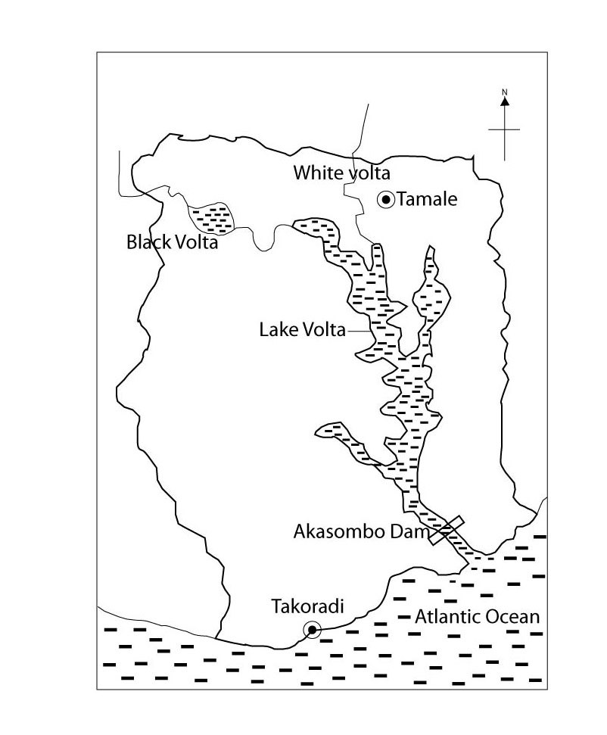SKETCH MAP OF GHANA SHOWING LAKE VOLTA AND THE ATLANTIC OCEAN, RIVERS, TOWNS AND THE AKASOMBO DAM

1. Presence of river Volta and water fall along its course for turning the turbines
2. Presence of a narrow river valley (gorge) for easy establishment of the dam.
3. Availability of a hard basement rocks to support the dam
4. Presence of extensive land for the establishment of the project as well as the large water reservoir
5. Presence of numerous rivers with constant flow of water e.g Black volta, R. white volta e.t.c
6. Heavy rains that led to floods
7. Presence of large supplies of raw materials for construction of the dam like water stones, sand e.t.c
8. Availability of large supplies of labour to work on the dam both skilled and unskilled.
9. Presence of advanced technology used in construction of the dam
10. Favourable government policy or the development of large scale multipurpose scheme
11. **(c) Benefits of the volta projected to Ghana**

* The volta project has led to the development of infrastructure like roads, railways, hospital e.t.c
* Generation of cheap HEP for both domestic and industrial purposes.
* Development of tourism industry because of the associated land forms thus an alternative source of foreign exchange
* Development of industries because of the cheap HEP produced
* Generation of employment opportunities to a number of people e.g technicians, mechanics, driver e.t.c
* Climate modification of surrounding areas due to the presence of large water reservoir behind the dam.
* Promotion of trade and international cooperation among countries through exportation of power.
* Generation of revenue for the government through taxation of the workers as well as companies.
* Creation of man- made lake

**(d) Steps taken to solve the above problems include;**

* Construction of concrete embankments to control flooding
* Spraying to control pests and diseases
* Regular dredging to remove silt from the reservoirs
* Treatment or recycling of industrial wastes before disposal
* Resettlement of the displaced people
* Carrying out afforestation and re-afforestation to improve on the bio-diversity
* Training and deployment of security personal
* Borrowing more from financial institution to develop the project.

Question 4

1. Graph paper …………….. 9 marks
2. (i) Wettest month is November with 380mm (01mark)

(ii) Mean annual rainfall is

$\frac{250+250+350+300+213+25+25+25+25+100+275+380+200}{1}$

= $\frac{2468}{1}$ = 2468 mm (01mark)

Mean annual temp range is

$$\frac{30+31+31+31+30+29+28+29+29+29+30}{12}$$

= $\frac{355}{12}$ = 29.58 29.60c (02marks)

1. **Characteristics for the climate station A**

* The temperature is evenly distributed throughout the year
* The area has a low annual temp range of 31- 28 = 30c
* The area experiences a hot temperature above the average of 290c
* The area receives a double maxima of rainfall ie it has two rainfall peaks march and November
* Less rainfall is received from June to August
* The starting receives rainfall throughout the year. (04marks)

1. **Problems faced by the people living around station A include;**

* Over flooding in the area, making settlement had for people around especially during rainy season
* Too cold and this makes area unfavourable for human settlement
* It likely to be a good breeding ground for disease vectors like mosquitos which scare man to settle in such areas.
* Such areas have dense forests which labour wild animals that scare away human settlements

id – 4

Ex- 4

O8

1. (a) (i) River 1- White Nile and 2 Blue nile

(ii) Dam 3 – sennar dam

(iii) Irrigation Schemes

4- Gezira Scheme

5- Managil

6- Kenana

(iv) Town &- Khartoum (07 marks)

1. **Conditions favouring the development of the Gerira irrigation scheme include**

* Presence of large supplies of water for irrigation provided by blue Nile and sennar dam.
* Presence of vast land for the establishment of the scheme.
* Availability of a gently sloping land that favoured irrigation under the influence of gravity
* A well-developed transport network
* Presence of fertile alluvial soils for cotton growing deposited by the blue Nile during flooding.
* Presence of low and unreliable rainfall because of the semi-arid condition calling for irrigation
* Scarcity of vegetation making clear easier and establishment of the scheme
* Presence of clay soil for easy construction of the canal
* Large supplier of labour to work on the plantation provided by the original inhabitants of the Gezira hills.
* Adequate capital for investment provided by the Gezira Board
* Large market of cotton both in Sudan and abroad e.g UK, Germany
* Sparse population ensuring large scale irrigation

Max 06 marks

1. **Benefits of the Gezira irrigation scheme include**

* Led to generation of revenue through taxation of the tenants.
* Provision of employment opportunities to the tenants improving the SOL
* Provision of various raw materials for the industries especially cotton to testile industries
* Development of urban centres
* Led to development of infrastructure like roads, railways, schools e.t.c
* A major source of income for the tenants for people enabling them to improve on their SOL
* Generation of foreign exchange through the exportation of cotton into UK, India, Italy
* Promoted research in the county into better cotton variests
* Led to diversification of the economy, widening the government tax base

Id – 4

Ex -4

08

1. **Problems that resulted from the Gezira irrigation scheme include;**

* The pests e.g birds, worms that destroy the crop
* Diseases like malaria and bilharzia which affects tenants
* Pollution from the industries that destroy the environment
* Displacement of people in expansion farm land
* Soil exhaustion due to monoculture
* Destruction of vegetation cover/deforestation
* Shortage of labour during the picking season
* Siltation which leads to blockage of canals calling for expensive dredging
* Growth of weeds e.g Rhizome

04 marks

1. (a) A SKETCH MAP OF EGYPT SHOWING WATER BODIES QQUATTARA DEPRESSION, SUEZ CANAL AND URBAN CENTRES

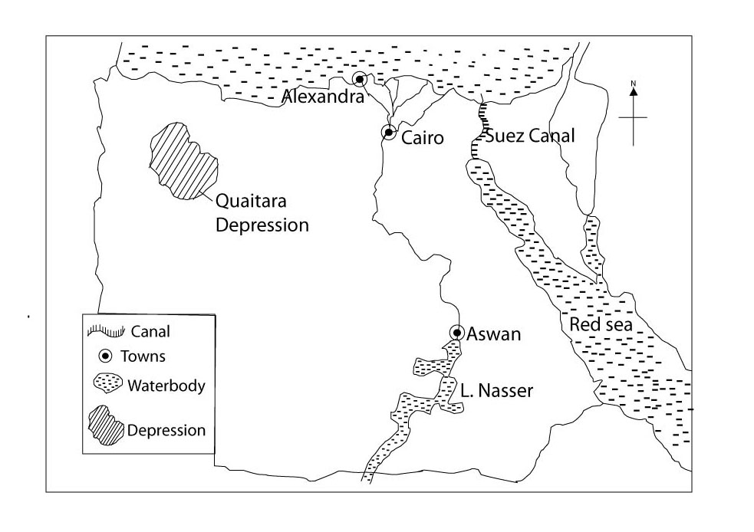

(b) Factor that have led to the growth of Cairo Asian urban centre include;

* Presence of many industrial establishments which provide employment to a large population
* Vailability plenty of HEP which provide energy used domestically and for industrial use.
* Presence of a hard basement rock for construction of firm and tall buildings
* The favourable government policy, promoting urban development through construction of sky scrapper
* The rapid population increase due to high fertility rate has big population in cairo
* The availability of carious minerals used in different industries like gold phosphate iron ore, petroleum
* Availability of cheap labour due to the large population has led to its urban growth
* The presence of improved transport and communication in form of water, canals, railways, roads e.t.c
* The rich agricultural hinterland of Cairo from the Nile delta and along the Nile

Max 07

1. Effects of urbanization on the physical environment include

* Attraction of large numbers of people which results in over crowding
* Pollution of the environment through discharge of the harmful industrial wastes into the atmosphere and water bodies
* Shortage of land for expansion for urban expansion and settlement
* Over exploitation of resources due to the even increasing population
* Unemployment due to shortage of jobs as a result of too many people coming in town
* Over population in the areas causing high population pressure on existing resources
* High crime rate such as theft, murder, assault, drug abuse e.t.c
* Traffic congestion causing delays in movement
* Provision of a large market for gods produced by the large population
* Easy access to social services such as health , education and transport facilities
* Generation of many employment opportunities to various professions such as doctors, lawyers, technicians
* Large revenue is collected by government through taxation of resident’s incomes and commercial enterprises.

1. Solutions to the effects of urbanization in Cairo may include;

* Vertical expansion of the town through the construction of sky scrappers to solve the problem of land shortage
* Recycling, treatment and proper disposal of harmful waste as well as acts of clean environment to control pollution
* Strengthening police through training to handle crimes
* Construction of wide roads with many lanes which can take may cars at ago
* Containerization to check of congestion at the post
* Construction of more manufacturing and service industries to create jobs for the unemployed
* Establishment of more public services e.g health centres, educational institutions, transport systems e.t.c to cater for the raising population.
* Restricting the number of immigrants to the city to control over population
* Urban planning to upgrade slum areas to better low income residential areas through provision of services like supply of water, electricity, gas e.t.c

max 04 marks

**STUDIES IN DEVELOPMENT**

**NORTH AMERICA**

1. (a) A SKETCH MAP OF CANADA SHOWING PROVINCES WHEAT EPORT ROUTES AND PORTS  
   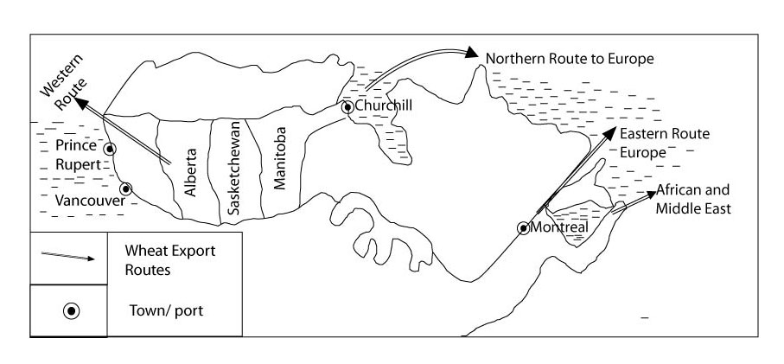
2. The physical factors which have favoured commercial wheat growing in Canada include

* The moderate rainfall received in the paires (500-100mm) suitable for wheat maturity growth
* The warm Chinook winds melt winter snow to increase moisture to the soils in summer
* The fertile charnozem soil for quick wheat growth
* The presence of prairie grass land which was easy to clear and establish farm of wheat.
* The flat landscape for easy mechanization
* A long growing season of up to a maximum of 120 days which is free from frost
* The presence of extensive land for large sized farms.

Max 07

1. Problems from over dependence on wheat include

* Pest and diseases which attack crops e.g Hessian fly, wheat rust
* Soil erosion due to monoculture destroying the soil quality
* Over dependence on external market with its related problem of trade restrictions
* Fluctuation of prices on the world market leading to low earning
* Competition for market with other wheat producers e.g Pakistan
* Limited labour force in busy harvesting periods
* Our production leading to reduced sales
* Prolonged drought leading to low output
* Soil exhaustion due to monoculture e.t.c

Max 06

1. Steps taken to solve the above problems include

* Use of the quota system to avoid falling prices
* Spraying to control pests and disease
* Crop diversification to include cereals e.g barley, maize to avoid over dependence on one crop.
* Application of fertilizers to restore fertility
* Diversification of agriculture practices to include animal rearing ( mixed farming) stabilizer income
* Use of better seed varieties that are resistant to drought and pets have been introduced
* Planting of the shelter belts tree to check on erosion

Question 8

1. Graph ……………… 9 marks
2. (i) Lowest Fish type caught----- Halibut fish

(ii) Highest fish type caught----- Lobster fish

1. Methods of catching fish in British Columbia include purse saining, grawling, drifting, long lining

**Purse Seining method**

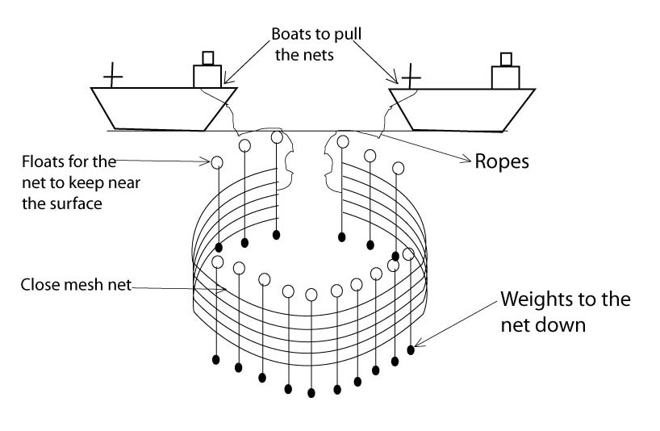

* This method is used in catching pelagic fish
* The purse seine net is laid out in a circle supported by floats at the top and weights at the bottom
* It is made to enclose a shoal of fish when the circle is completed, the rope is pulled the close the bottom of the net of fish trapped then scooped out of the net into the boats

Any method

2 x3 = 06

**Trawling method**

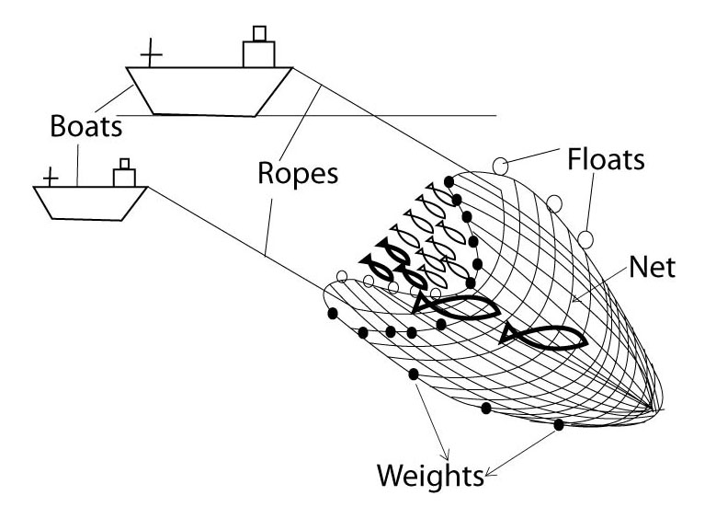

This method is mainly used for catching demersed fish. A trawl is cone shaped net with a circular mouth. The wide open entrance has flats at the top and weights of the bottom

The net is tied to one boat which keeps it dragged along the sea flood, when its full, it is pulled and emptied into the ship

**Drifting method**

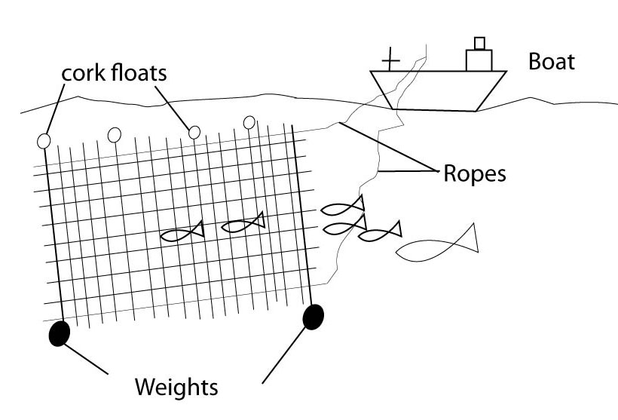

A drift net used by hanging it vertically in the sea like tennis net, it is filled with floats on the top and weights below a drift net is mobile and is allowed to drift with the converted currents its used on high seas to capture a wide range of fish like tuna salmon and squid. The fish is caught by their gills in the mesh of the net and unable to more backwards or informed due to its large body.

1. (d**) Physical condition favouring fishing in British Columbia include;**

* Warm and cold ocean currents creating ideal conditions for the growth of plankton to feed fish
* The long coastline with sheltered bags offering good sites for the development of fishing ports and villages
* The many off shore islands along the coast of Vancouver and queen charlotte increase the area of fish landing sites
* The cool temperate climate which makes the preservation of fish relatively easy
* The ice free coasts during winter hence fishing can take place all year round
* The many fish species of a high commercial value
* The large continental shelf, which encourages sunshine penetration necessary for plankton growth
* The large quantities of timber for the construction of fishing vessels
* The excellent spawing ground for the salmon fish e.g river skeena and river Skeena provide fish and fresh water for breeding of young fish

Id- 4 max

Ex- 4 max

08 max

1. (a) Naming the;
2. Mountain rangers marked K – coastal ranges
3. River marked L – R Sacramento
4. Valley marked M – Central Valley
5. Dam Marked N- Shasta dam
6. Canal marked P- Delta Mendota canal
7. Town Marked Q – San Francisco

R – San Diego

1. **Factors which have favoured cotton growing in California**

* The sunny conditions which allow ripening of cotton and harvesting
* Existence of large expenses of land for cotton growing
* Presence of numerous rivers for irrigation e.g river Fraser
* Hot temps averaging between 230c – 260c to help during flowering and ripening periods
* The gentle slopes and plains to enable use of machinery and canals for irrigation
* The deep, well drained soils for quick cotton growth
* The heavy rainfall between 500mm- 1000mm in early days which support cotton growth
* The arid areas of the central valley e.g sa joaqum with low incidence of pests and disease
* The high technology e.g cloud seeding to bring about artificial with scientific crop husbandry e.t.c.
* The well-developed transport system by rail, roads and water e.t.c
* The large market for marketing cotton products
* The favourable government policy to extend cotton growing to new areas
* The large supply of migrant labour from Asia, mexico, phillipines to work on cotton farms.

Max 08

1. **Contribution of cotton growing to the development of California**.

* Development of agro-based industries that process cotton into finished products
* A source of foreign exchange from exports to develop infrastructures
* Improvement of international trade leading to international relation
* Generation of renue through taxation of the people and companies
* Provision of large market for agro-based industries e.g fertilisers, insectcides, pestcides e.t.c
* Growth of towns/urbanization with its related advantages like infrastructure development
* A source of raw materials for the industries e.g textiles, animals feeds
* Flood control through the use of river waters for irrigation on the cotton plantation
* Diversification of the economy thus awide tax base
* A source of employment to people thus improved S.O.L

ID – 3

EX- 3

06

1. A SKETCH MAP OF BELGIUM SHOWING AREAS OF NORTICULTURAL CROPS, RIVERS, FORESTED AREA AND TWO DIARY FARMING AREAS

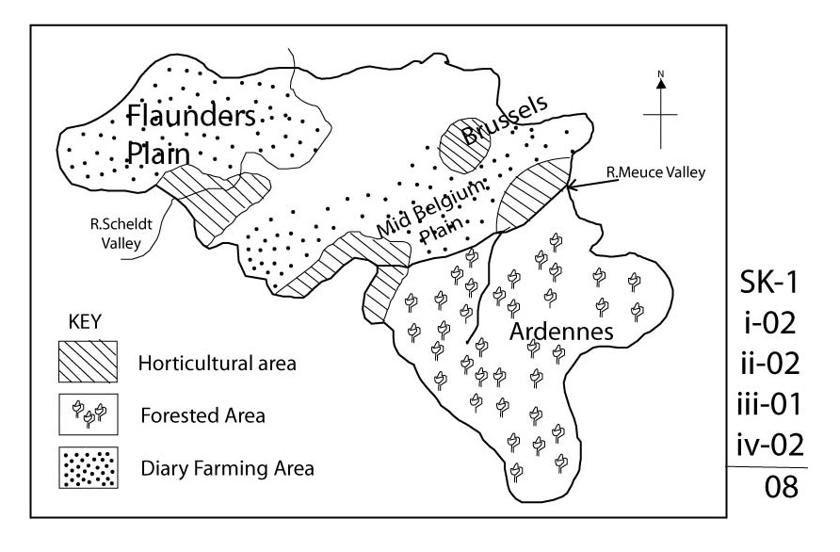

1. **Conditions that have favoured horticulture in Belgium include;**

* Presence of large capital to invest in agricultural
* Presence of adequate supplies of skilled labour force in agriculture which leads to increase output.
* High level of technology e.g use of glass houses.
* Land reclamation efforts which have increased land for agriculture
* Intensive research leading to high crop yield varieties
* Large cooperative movement which has led to marketing of the crops
* Developed transport system to enable products quickly reach the market
* Large market for fresh vegetables in the urban centres e.g Brussels
* Fertile soils favouring growing of cereals, fruits and vegetables
* Favourable government policy of promoting agriculture to diversity the economy
* Presence of mild, maritime climate in warm and wet summers and fairly cold winters favouring the growth of cereals, vegetables

Max 06

1. **Problems facing horticulture in Belgium include;**

* High cost of production e.g use of expensive glass houses
* Pests and diseases which attack the crops
* Price fluctuation on the world market
* Flooding of rivers which destroys crops e.g in the R. meuse valley
* Shortage of labour in busy periods
* Limited land for cultivation then expension is not possible
* Competition for market in the other contries like Netherlands, Switzerland e.t.c
* Salrisation of soil resulting from the sea waters around the coastal areas.
* Presence of infertile soils in some areas

Max 06

1. (i) Other crops grown in California include;

* Barley, grapes, peaches, wheat, sugarbeat
* Oranges, rices, lemon, dates, vegetables

Max 02

(ii) States in the new cotton belt of North America are;

* California – Texas, Arizona
* Oklahoma – Arkansas max 02

**REGION II – RHINE LANDS**

1. (a) Graph ------------------------------------ 07

(b) Glacial features may include;

* Pyramid peaks --- hanging valleys
* Arcles ---- u- shaped valleys
* Cornies/cirques --- Tarn

1. Arete it’s a sharp elongated knife-shaped like feature formed between two cornies. Arête are formed when two cornies are formed adjacent to each other. This will leave a sharp ridge separating them.
2. Pyramidal Peak

It’s a sharp pointed feature forming the peal of the mountain. It resembles a pyramid and therefore formed when three or more carries are formed near the mountain peak

U-shaped valley

It’s a broad, flat bottomed, steep sided valley with a U-shaped cross profile. Its formed when glacious moving down from, mountains erode the interlocking spurs to broaden the valley.

**Cornie/cirque**

It’s an arm-chair shaped like feature created by glacial erosion. Its starts with a small crack on the mountain where water will enter, upon a fall in temperature, the water will freeze from with in the crack thus, enlarging it further. The repeated process will produce numerous rocks causing individual particles to peel off and moved down the valley to produce carrier.

**Tarn** it’s a glacial lake formed when a cirque in filled with water

Any 3 x3 09

1. **Problems facing land use in Alps include**

* Excessive cold winter which limits settlement
* Transport difficulty due to the rugged nature of the land scape
* Presence of infertile soils that limits agriculture; activities
* Severe soil erosion by moving glacious that destroys man’s property and communication lines
* Reduced rainfall on the lee ward side thus leading to aridity and drought conditions and infertility of soils
* Labour shortage avoiding the dump weather

Id – 3m

Ex- 3m

06

1. **Steps being taken to solve the problems include**

* Electrification of railways to solve the transport problems
* Settling in warm sheltered valleys of river Rhone and Rhine
* Use of fertilisers in agriculture
* Buying of winter clothes and indoor warming to regulate temperature
* Use of mechanization to solve labour shortage
* Irrigation on the leeward sides

03

25

1. **Solution to the problems faced by horticulture include**

* Diversification of agricultural practice
* Spraying to control pests and disease
* Application of fertilizers to improve on soil fertility
* Use of glass houses which allows growth of some crops throughout the year
* Importation of labour from neighboring countries
* Reclamation of land from swamps to increase land for agriculture
* Use of quota to systems to control competition
* Use of dykes to protect farmlands from flooding
* Acquisition of loans from cooperative to get capital (max 05)

1. a) (i) River Tributaries marked A- R. Mossel, B- R. Neckar

(ii) Countries 1- Germany , 2- Netherlands

(iii) Ports C – Rotter dam, D Basel port

06

1. **Factors which have led to development of the Rhine into an international watering include;**

* Deep river channel which accommodates large ocean going vessels
* High level technology at the ports for quick shipment, loading and off-loading of goods
* Large capital to purchase big oceans going vessels to construct modern port facilities
* Presence of a rich hinterland ie the rubber industrial region, the Rhine rift valley agricultural areas and Rhine delta since R. Rhine serves many land locked countries
* Presence of melting glaciers in the Swiss Alps to constantly increase the volume of the Rhine water.
* Presence of the Rhine river which flows all the Rhine land countries e.g Switzerland, Germany e.t.c
* It has a large network of tributaries such as R. mosel, R, main, R. Neckar which increase the hinterland and volume of water in the Rhine river.
* Presence of ice-free conditions all the year around along the navigable stretch

Max 08

1. The importance of the Rhine water way to the Rhine lands are;

* Promotion of international relations through export trade within the Rhine lands
* Provision of cheap transport for bulky goods
* Development of industries in western Europe
* Provision of employment opportunities to which have raised or improved people S.O.C
* Has facilitated the development of mining sector in the Ruhr region and France.
* Development of urban Centre/ports like Basel, Rotterdam, mainz, Cologue e.t.c
* Development of agriculture through provision of accessibility to agricultural areas especially for vines
* Provision of revenue to the Rhine lands through taxation of goods and companies.

1. (i) problems faced by countries using the Rhine water way include;

* Congestion at ports which leads to delays
* Occasional flooding/sea incursions especially in the lower Rhine areas
* Siltation which calls for expensive dredging fog causing poor visibility
* Pollution of water, land and air which are harmful to the environment.
* High taxes imposed on the shipment of goods along the Rhine water way.

(ii) Steps being taken to improve navigation on the Rhine water way include;

* Containerization to help in quick loading and offloading of goods;
* Strict adherence to time table of moving vessels
* Anti-pollution laws to maintain air and water quality standards
* Removal of silt from the water way/dredging of the water way.
* Construction of artificial levees and dykes to control floods
* Use of flood lights/strong lights to improve visibility along the water way due to snog.
* Construction of more by-pass canals to reduce congestion

Max 02

25

1. 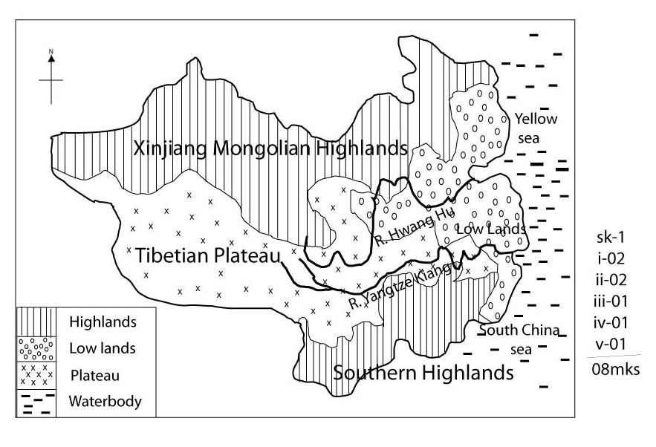(a) A sketch map of china showing rivers, water bodies, lowlands area, plateau and highlands areas

(b) Process which led to formation of the highland areas in china

* The highlands were formed through the process of folding.
* They were formed as a result of compression forces acting upon alternating had and soft rocks of the Earth's crust.
* One to the exerted on the rocks, they will bend and rise of above the normal level.
* 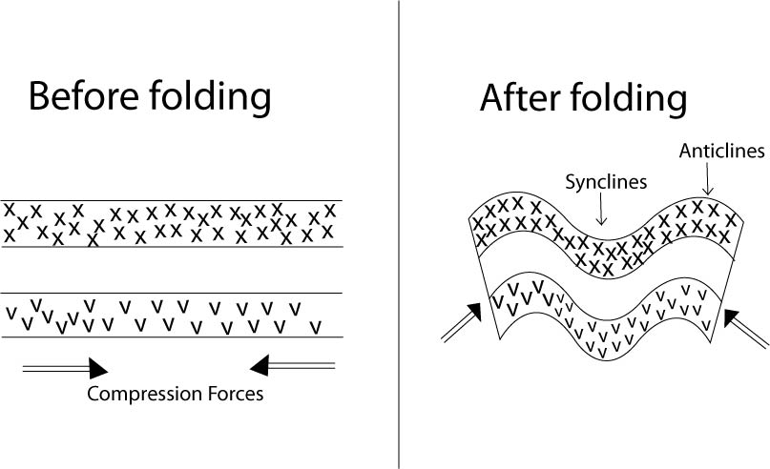The rising blocks will form anticlines (highlands while bending rocks down will form synclines

(c) Problems of people living in highland areas of china include;

* Severe soil erosion of the loss soil caused by radiating rivers like R tangtze
* Remoteness in the region in terms of communication lines
* Limited agriculture is carried out due to the rugged terrain.
* The people suffer from extreme coldness due to intensive snow and ice cover
* Drought is very serious in the area, since it lacks, vegetation that leads to rainfall formation especially on the lee-ward sides
* Much of the landscape area is a waste land covered by rocks and gravel.

Id -04

Ex – 04

(d) Steps being taken to solve problems of people in highland areas of china

* Practicing afforestation
* Encouraging people to settle in low lying areas
* Government attention to establish modern transport routes in such areas
* Establishment of wildlife conservation centres which attract tourists
* Terracing and use of contour ploughing
* Irrigation to reduce aridity especially on the lee ward sides of highlands

Mx 04

25

1. (a) Percentage change in population between 1980 and 2000

% change = $\left(\frac{1,271,800-981,200}{981,200}\right)$ x 100

= $\frac{290600}{981200}$ x 100

= 29.6%

03

(b) A line graph 06

(c) Factors which have led to the trend in population shown on the graph, include;

* Availability of various mineral resources that attract people to work in the mines
* The efficient transport and communication system attracting people for easy accessibility
* The fertile soils attract people for agriculture like in north china plains
* Urbanizations attract people on the eastern seaboard for social amenities
* High level industrial activity attract people for employment
* Presence of rich loss soil on the north china plains support agriculture

Id – 4

Ex – 4

08

(d) (i) Population problems faced in china;

* Limited accommodation leading to the development of slums
* Congestion of people and vehicles that lead to delays
* Unemployment leading to idleness and then high crime rates
* Too much pressure on the land and other available social economic infrastructure leading to depletion of natural resources
* Food shortage leading to malnutrition'
* Flooding is a result of land degradation easy spread of disease due to over crowding

Max 05

(ii) Steps being taken to solve the problems in d(i) above.

* Adoption of population policy of family planning ie over child policy
* Modernizing agriculture to increase productivity
* Importation of food to supplement domestic resources
* The government policy of the "Green revolution" that is aimed at increasing quality and quantity of food
* Diversification of the economy to provide alternative jobs
* Establishment of health centres to help treat diseases
* Creation of storeyed building or vertical expansion

Max 03

25

1. (i) An agricultural commence is a system of farming where farmers are organized into families to form production teams which in turn join to form production brigade

02

(ii) Name any two agriculture communes;

* Red light commune
* Forah tung pepsi commune
* Young tarn
* Channshan

(b) Organization of the agricultural communes in china;

* Five families make up one production team
* Ten production teams make one brigade
* Five brigades make up a commune
* Each commune is expected to produce on community in a given/period of time in specific quantities.
* Leadership is periodically elected to organize the communal daily activities.
* Individuals are expected to work for six days in a week
* Workers are paid wages depending on the profit occurring to a commune.

Any 4 x2= 08

(c) Problems faced by farmers on the agricultural communes in china include;

* No independence in decision making which stifles creativity and innovation
* Lack of individual freedom to choose what should be grown
* Over centralized farm operations i.e. red type or bureaucracy
* High level of crop failure
* Poor planning leading to mis-allocation of resources e.g land , labour etc.
* Hostile attitude of the people due to the Harsh environment
* No individual land ownership hence people don’t care about the farms much.
* Low initiative to invest on land maintance
* Pest and diseases that destroy crops

Id – 4mx

Ex -4 mx

08

**(d) Measure being to address the problems in (c) above**

* Introduction of new crops/ crop diversification
* Practicing of contour ploughing and terracing
* Establishment of agro-based and other light industries to diversify the economy
* Improved irrigation through use of underground irrigation channels
* Application of fertilizers/use of organic manure
* Establishment of demonstration farms.

